**DAILY ONLINE ACTIVITIES SUMMARY**

|  |  |  |  |  |  |  |  |  |
| --- | --- | --- | --- | --- | --- | --- | --- | --- |
| **Date:** | | **23rd May 2020** | | | | | | |
| **Name of the Faculty** | | **VENKATESH** | | | | | | |
| **No. of Students Allotted for monitoring** | | | | | **27** | | | |
| **Progress** | | | | | **Good** | | | |
| **Whether collected report from all the allotted students** | | | | | **27** | | | |
| **Online Test Summary** | | | | | | | | |
| **Subject** |  | | | | | | | |
| **Semester** |  | | | **Duration** | |  | | |
| **No. of students Taken** | | |  | **Passing %** | |  | | |
| **Certification Course Summary** | | | | | | | | |
| **Course** | | 1. **Python Programing – Working with Lists and Files** 2. **Two days Online FDP on IoT and Cyber Security** | | | | | | |
| **Certificate Provider** | | 1. **Alison** 2. **Cambridge Institute of Technology** | | | | | **Duration** | 1. **Three Hours** 2. **Two days** |
| **Coding Challenges** | | | | | | | | |
| **Problem Statement: Write a C Program to Generate First N Triangular Numbers** | | | | | | | | |
| **Status: Total 35 Students were solved.** | | | | | | | | |
| **Uploaded the report in Github** | | | | | **Yes** | | | |
| **If yes Repository name** | | | | | [https://github.com/Venkateshbhat2007/](https://github.com/Venkateshbhat2007/Online-Daily-Activities) | | | |
| **Uploaded the report in slack** | | | | | **Yes** | | | |

Certification Course: **Python Programming - Working with Lists and Files - Final Assessment**

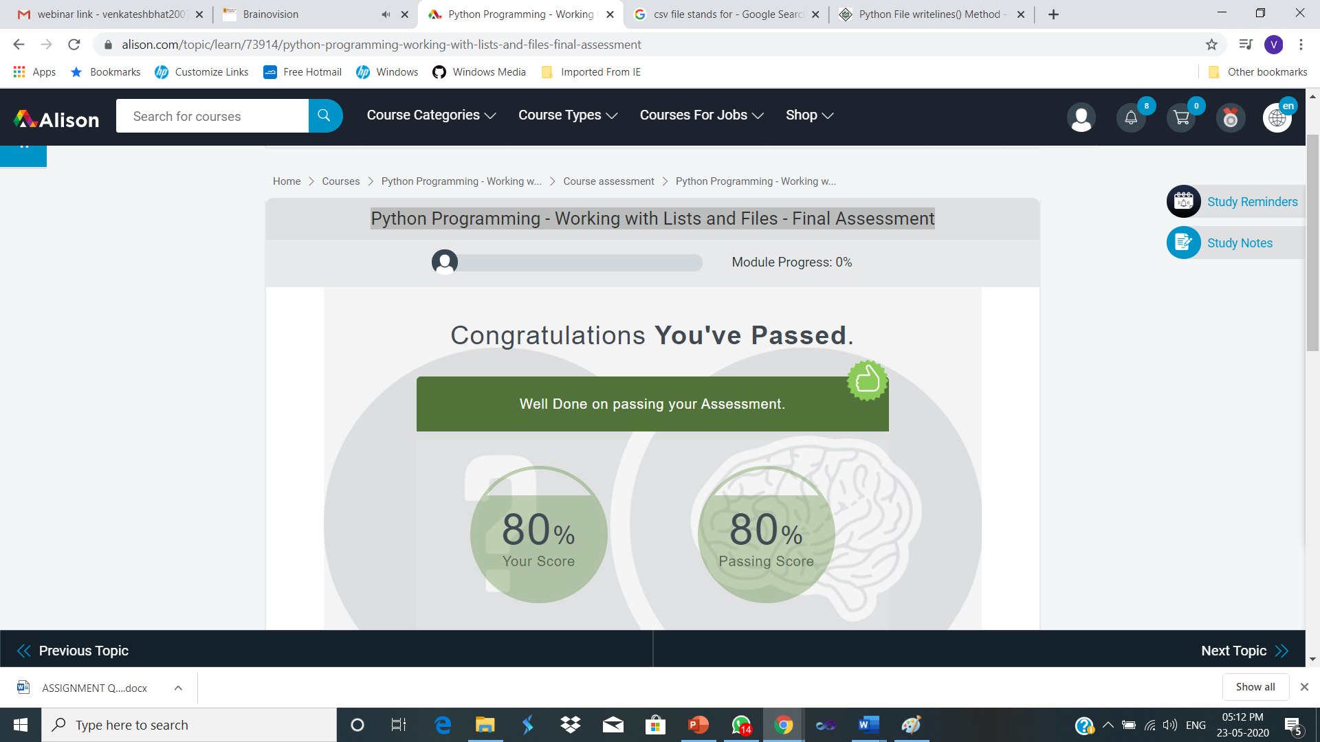

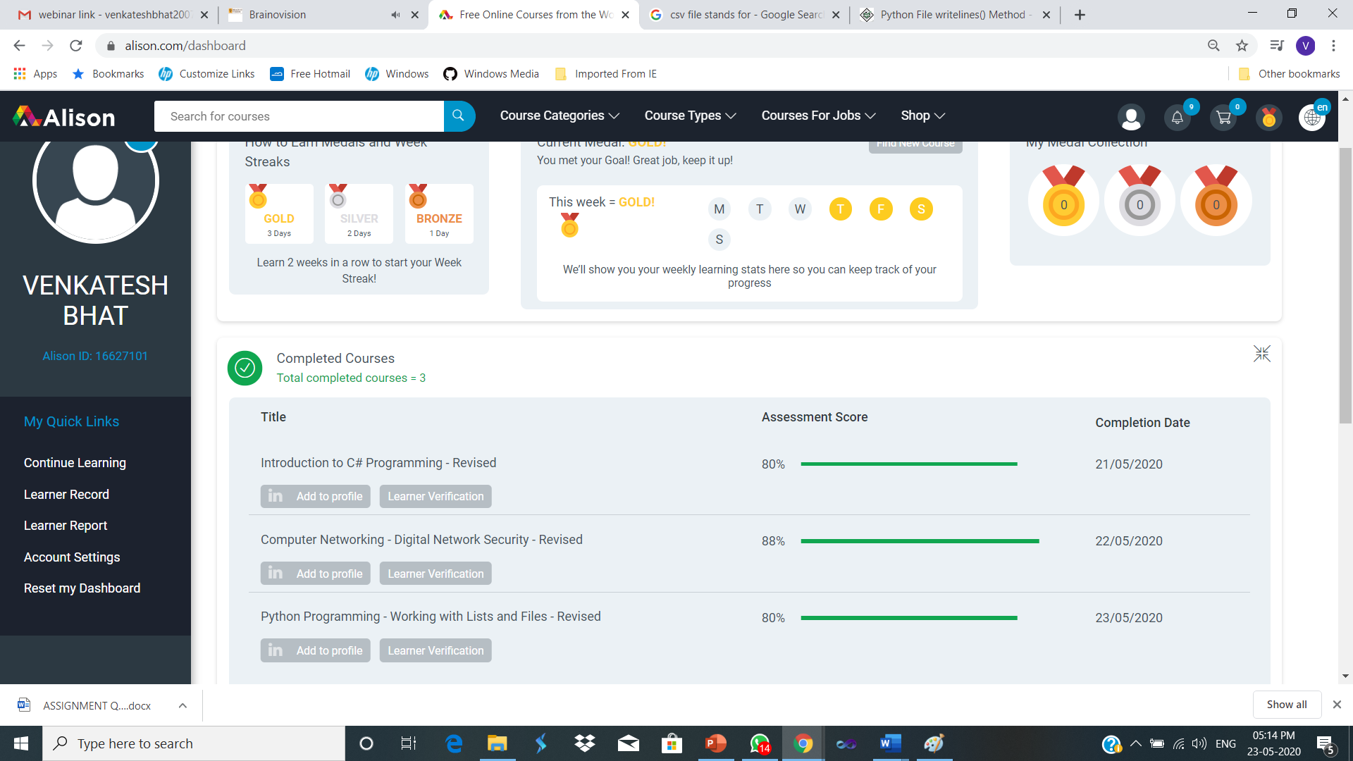

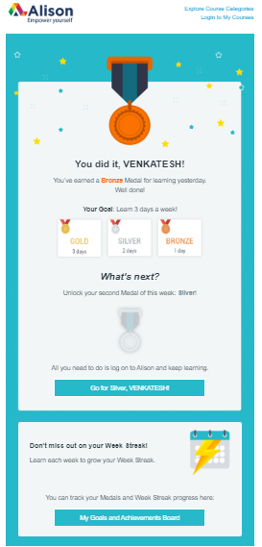

Attended two days Online FDP on “**Online Faculty Development Program on IoT and Cyber Security - an Industry Perspective**”

Attending One Week Online FDP on “**Artificial Intelligence**” in Association with Computer Society of India, National youth Council of India and Brain O Vision Services Pvt. Ltd., Hyderabad

**SECOND DAY OF THE FDP: IoT and Cyber Security – an Industry Perspective**

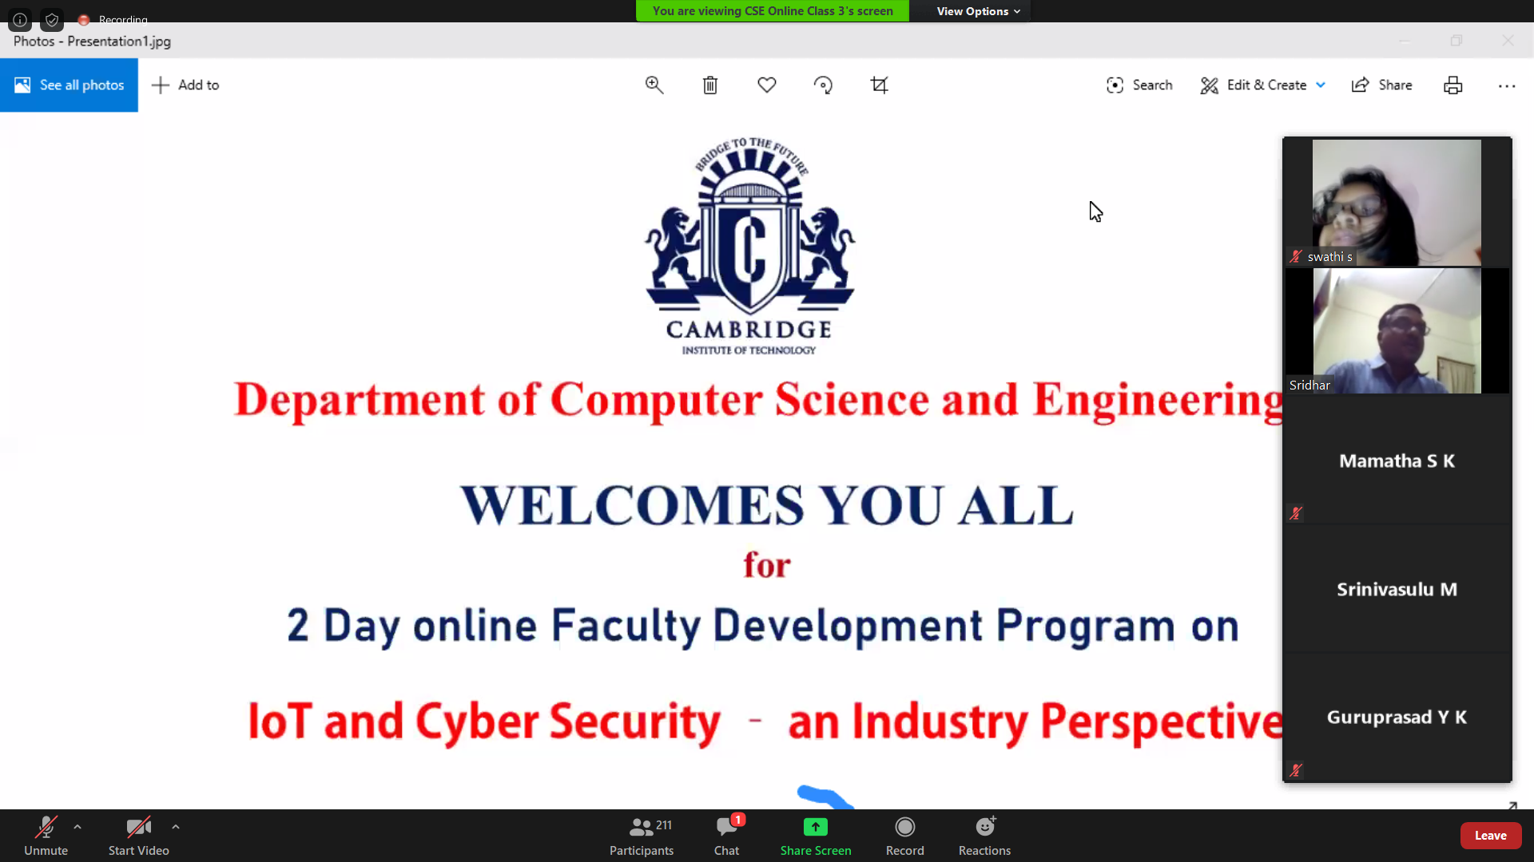

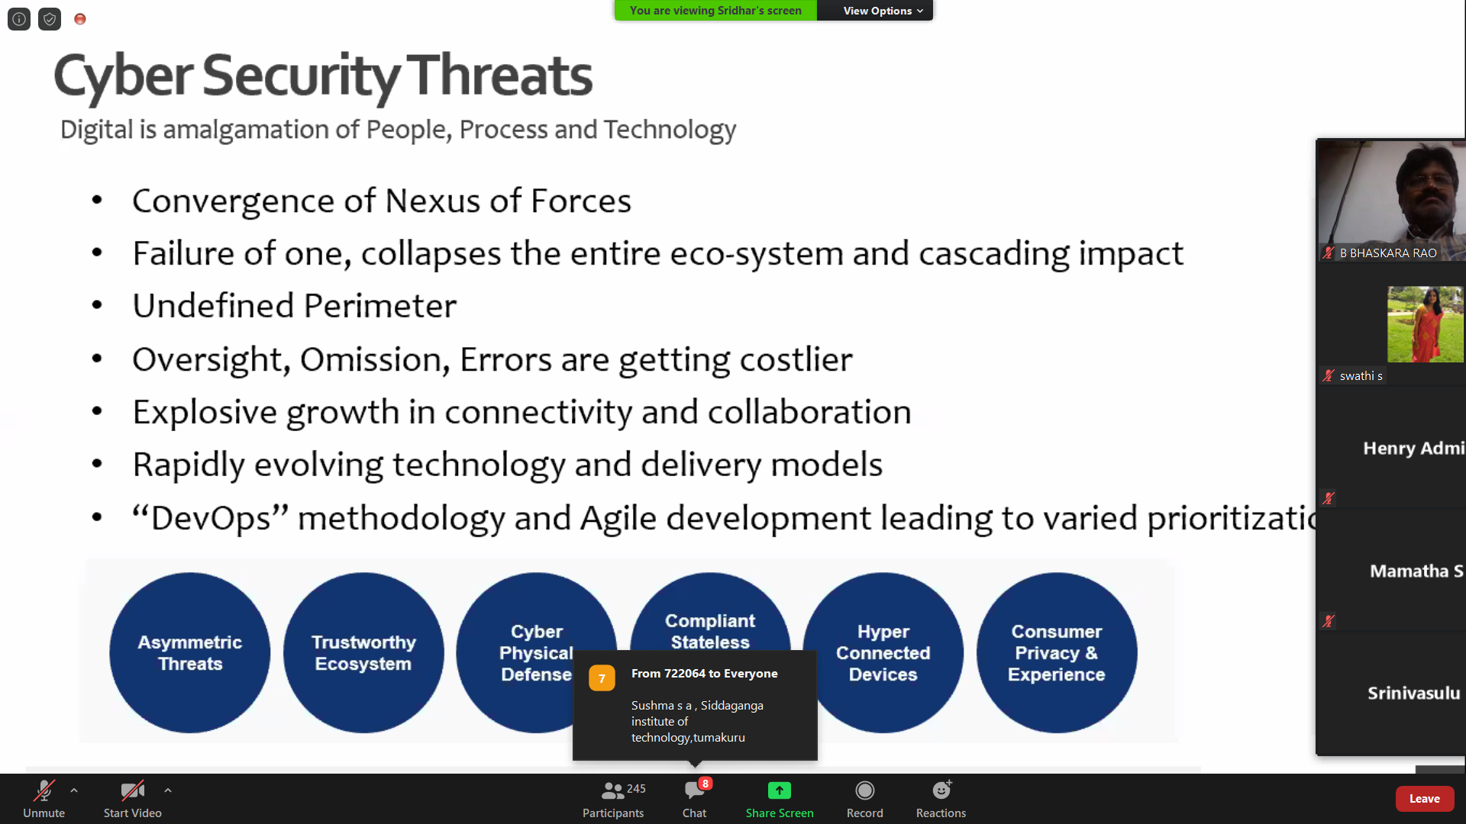

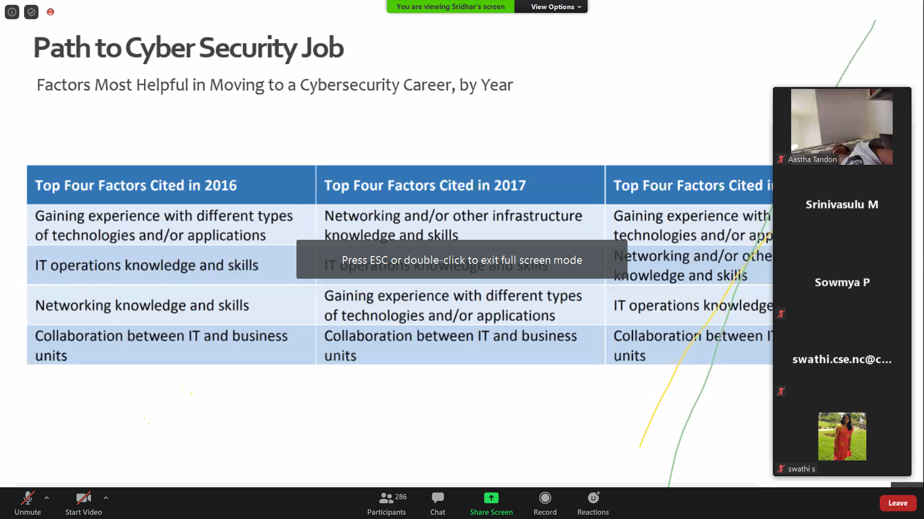

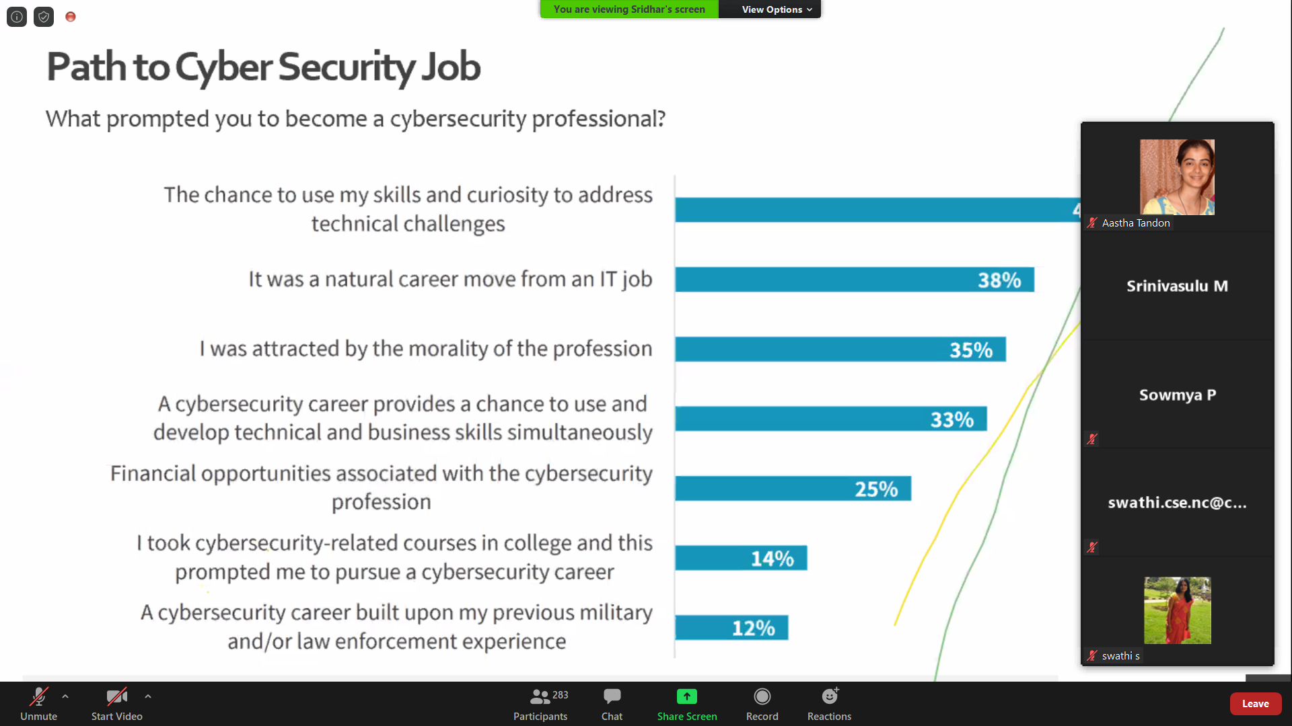

Webinar Attended:

***"IOT and Cyber Security - an Industry Perspective".***

**Conducted By:**

**Department of Computer Science and Engineering,**

**Cambridge Institute of Technology,**

